Discussion topics from Little Letters: an introduction to genetics

Within the book, themes and concepts on genes and genetics are subtly introduced. For some children, you might want to expand on these ideas and encourage further discussion to promote deeper understanding. You can begin by reading the relevant section in the book – the pictures will help guide you to the right section. Below are some suggestions for discussion topics, you don’t need to cover all of them:

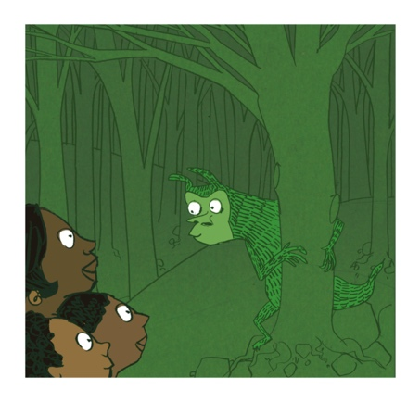 | The rinkidink is described as having a long tail, athletic shoulders and arms and green fur and body. What might that tell you about how they live?  These features (adaptations) might help them climb and live in trees. Arms and shoulders for climbing and swinging (imagine a gibbon), a long tail for balance (imagine a squirrel or monkey) and green colouration for camouflage in leaves (imagine a zebra or a chameleon).
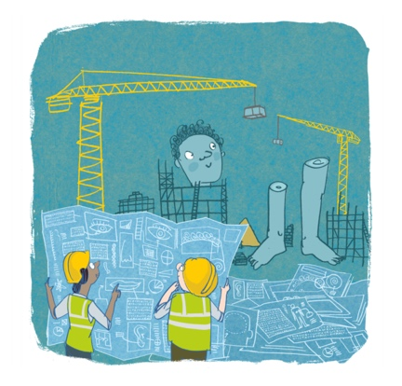 | Every living thing on the planet uses the same DNA code – ATCG – we are all the same. From viruses and bacteria, to plants and animals. Why? And how can scientists use this to help study living things?  You are made of lots of cells, but when life first began (a very long time ago), it could only exist as one cell. Scientists think the reason we all share the same code is because all things that are alive today (if you follow their parents and grandparents and great grandparents, further and further back) started from one type of cell that had the code ATCG.  Because all living things share the same code it means we can look for similar code across different animals, and if we understand how this code works in one animal, it gives us a big clue as to what it might be doing in another animal.
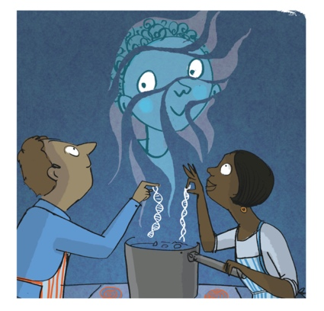 | Why do children tend to look a bit like their mum or dad, or their brothers and sisters?  Half of the DNA sequence in your cells is the same as your mum’s and half is the same as your dad’s, all jumbled up. So you might have the same bit of DNA (or gene) that makes your dad’s eye colour, and a different bit that makes your mum’s nose shape. When humans, or any animal, have a baby it is made up of DNA from both parents, and this is why families tend to share similar features. (Heritability)
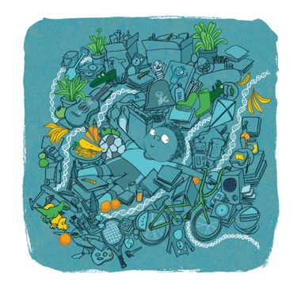 | Are we the way we are because of our DNA and genes? What about our personality or hobbies, are they in our genes too?  You are the way you are not just because of your genes, but also because of where you’ve grown up. Things like the food you eat will be important in how tall you grow (although your genes play a part too). Or whether you have someone football mad in your house, will probably have an effect on whether you love (or hate) football. What if you had been brought up in a different country, do you think you would like and do all the same things even though your DNA would be the same?
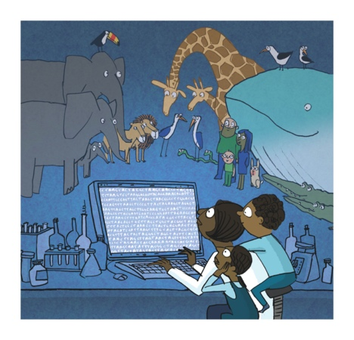 | In the story, Berry tries to match the DNA from the rinkidink to other animals. But why would the same type of animals have the same DNA?  People in the same family have DNA which is more alike. Animals that are more similar will also have DNA that is more alike. For example, although your DNA most like the people in your family, it is also almost exactly the same as the person sitting next to you (99.9%). Just a few differences will make you look different, but underneath you are the same. The same is true for any group of animals. The more different two animals are, the more their DNA will be different. For example, a lion and a tiger are both types of cat (very big ones), and their DNA will be quite similar in lots of places, but a lion and crocodile, which are very different animals, will be different in more places.  (The activity might help support this concept)

Additional general discussion topic:

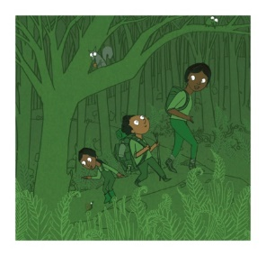 | Challenge their ideas around stereotypes.  What type of person do you think of when you imagine a scientist. Does Berry match the person you imagine? What’s the same, what’s different? Do you think most scientists look and act a certain way?

